Creating a posting

Last Revised: October 2016
  - User Guide

INTRODUCTION

PeopleAdmin Web Address
https://unk.peopleadmin.com/hr/

PeopleAdmin supports the following browsers:
- Chrome
- Firefox
- Internet Explorer version 9+
- Safari
PeopleAdmin requires you to have Adobe Acrobat Reader. This is a free download available at www.Adobe.com.

Log-In Screen
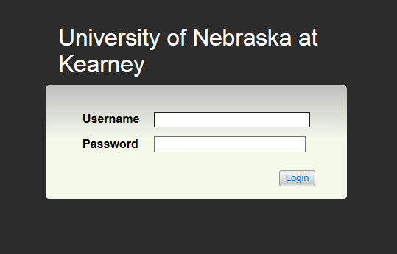
Username and Password are the same as EASI

Username: First part of email address (i.e. smithaj)
Password: EASI Password

Home Screen
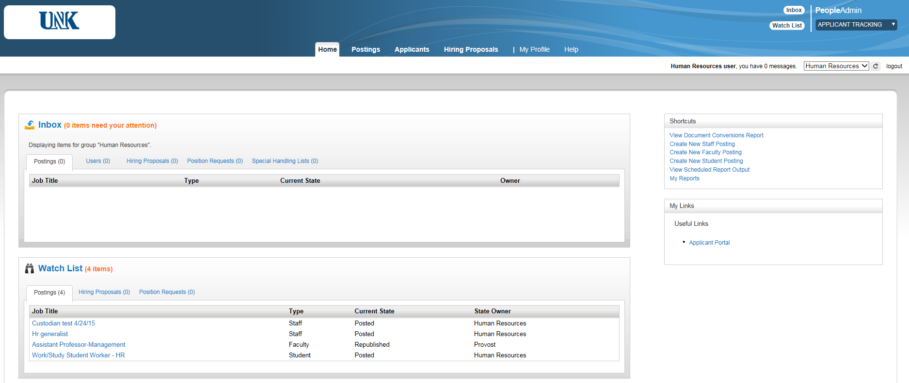
6..
5..
4 ..
3..
2..
1..
Note: If changing user roles, select desired role from drop down in the upper right-hand corner and click to confirm change

1 | Inbox | Items which require your attention
2 | Watch List | Items you would like to watch as they move through the approval process
3 | Tabs | Navigate between postings, applicants, etc.
4 | Shortcuts | Quick links to important areas (i.e. create a staff posting)
5 | My Links | Links to useful external websites
6 | Current Group | Change to correct user group (Search Chair, Originator, etc.)

CREATE A POSTING

There are three types of postings:
- Staff: Office/Service, Managerial/Professional, Administrative, Temporary, etc
- Faculty: Adjunt, Lecturer, Professor, etc
- Student: Graduate Assistants, Student Worker, Work Study

Select Originator Role (or Search Chair if you have this group and are the search chair for the posting)

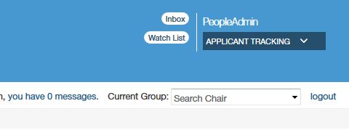
On Home Page under Shortcuts, click Create New (Staff, Faculty, Student) or Select appropriate position type from Postings Tab and click the orange button
- Create from Position Type – brand new blank posting (initially every posting will be created this way)
- Create from Posting – create from a previous similar posting

Posting Settings Page

The following example is based on selecting Create from Position Type
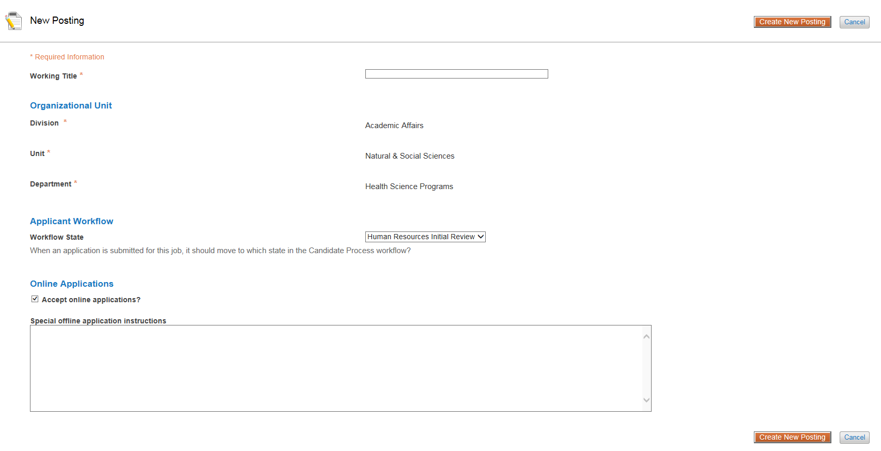

Working Title | This is the job title the applicant will see. Enter title and department; i.e. Professor, Biology; Custodian (Part-Time) Facilities. Include any position specific information in parentheses ( i.e. 1 yr appt; part-time)
Organizational Unit | Should default to Division, Unit, Department based on your credentials. If any of this information is incorrect or out of date, please contact HR.
Applicant Workflow | Defaults to Human Resources Initial Review
Accept Online Applications | Keep this checked to allow the job to be posted online to all applicants  ***Uncheck box only if you are completing the search process through an outside firm
Special Offline Application Instructions | List any instructions, i.e. link to outside firm’s employment website

When you have completed all fields, click on the orange button

Position Details
Enter posting information.

*All required fields are marked with an asterisk and are required to send to next approver
*Proofread carefully and utilize Check Spelling feature

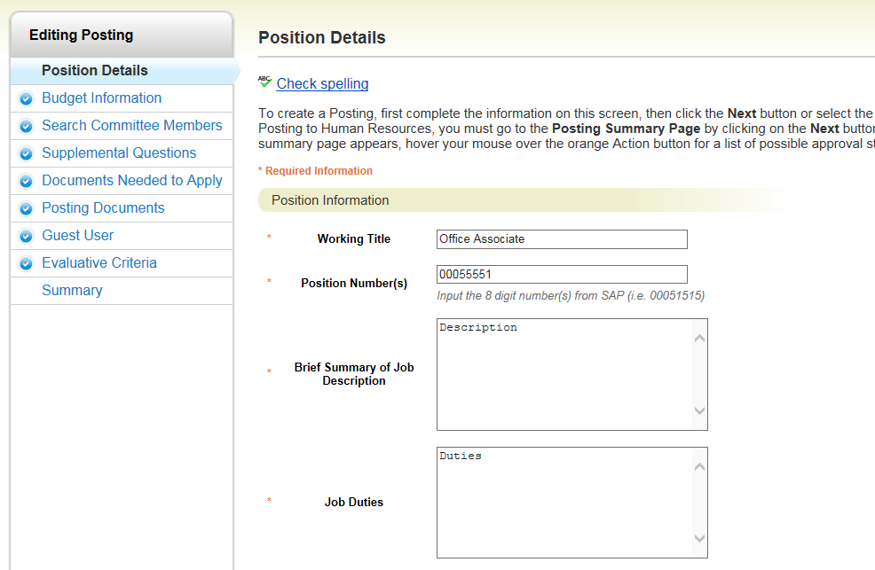

Make sure to click Save or Next to update any changes. You will be able to save changes even if you do not have all of the required fields completed. The system will automatically log you out after 60 minutes of no activity.

Position Information
Working Title | This is the job title the applicant will see. Enter title and department; i.e. Professor, Biology; Custodian (Part-Time) Facilities. Include any position specific information in parentheses ( i.e. 1 yr appt; part-time)
Positon Number(s) | i.e. 00055555 Replacing current or previous employee: see SAP screen 9001(Appointments) New position: enter new position number, or if unknown enter all zeros
Justification for Searching Position | Enter reason for filling position (usually replacing retiring or resigning employee)
If this is an existing position (replacing staff), was it reclassified for this posting? | Indicate whether the existing position was reclassified. Select “no” if it was not OR if it was not an existing position.
Will this position be searched? | Yes: posting will go through normal search procedures No: Position Justification and Search Waiver must be submitted
Was a search waiver submitted? | Note: Search waiver must be submitted to HR for approvals
If the position will not be searched, please indicate why: | Indicate why search process in being waived
Rank - Faculty Only | Select appropriate rank
Tenure - Faculty Only | Select Not Applicable, Non Tenure Track (Lecturer and Temporary), Tenure Track , or Tenured
Brief Summary of Job Description | i.e. The Biology Department is seeking a Tenure Track Associate Professor for the Fall of 2015
Job Duties | Use most updated job description. If you do not have a current job description, please call 8522.
Required Qualifications | List required qualifications
Preferred Qualifications | List preferred qualifications
Physical Demands | List physical requirements; i.e. must be able to lift 50 pounds
Schedule | Hourly position: enter days and hours; i.e. M-F, 8am-5pm, 40 hours Salaried: List normal working hours and other schedule information
Desired Start Date | Enter planned date that employee will begin job
Position End Date (if temporary) | Enter planned end date for position if applicable
Special Instructions to Applicant | List any specific instructions, especially if you require a minimum number of references; i.e. please send three letters of recommendation to Search Chair, 905 W 25th St, Kearney, NE 68849 or please include three professional references
Special Conditions for Eligibility | List special conditions; i.e. candidate selected must complete proficiency test

Posting Detail Information
Posting Number | Prepopulates
Posting Date | Today's Date
Close Date | Date you want position removed from PeopleAdmin Site
Open Until Filled | Yes: posting will remain on PeopleAdmin until marked as filled and closed  No: posting will have an end date  Note: You cannot select both a close date and select Yes for Open Until Filled
Date Application Review Begins | Allow sufficient time for approval process (especially for new positions) and also for applicants to apply. Review dates will be adjusted according to approval and advertising deadlines. You can also write immediately instead of typing a date
Number of Vacancies | List number of vacancies
Search Chair | Enter Search Chair name. NOTE: The name you select here will typically be the next approver for the posting. If you are the search chair, enter your name. If the name you want does not appear, please contact HR.
Job Term | Select appropriate term
List Type | Regular or Regular and Promotional: jobs open to the public Promotional Only: job openings open only to UNK employees (Internal Search) Departmental Promotional Only: job openings that are open only to employees of specific UNK department.
Position Type | Existing Position: replacement of currently or previously held position New Position: Newly classified
Job Title in SAP | The job title exactly as it appears in SAP on screen 001 – Organizational Assignment Screen.
Job Title Code | 8 digit number listed as “Class Code” at top of web page or SAP Screen 001 – Organizational Assignment (Job Key)… i.e. 49271701 is the Job Title Code for a Custodian.
Employee Subgroup | Select appropriate subgroup: see SAP screen 9001 – Appointments (located directly under the incumbent name)
Leave Plan Code | Select appropriate code. Faculty: usually Monthly Not Eligible Vacation/Sick Leave  Office/Service: Biweekly Office/Service Vacation/Sick Leave  Managerial Professional: Regular Managerial/Professional Salaried or Hourly (depending on the Employee Subgroup above)
Wage Type Code | Select appropriate code Faculty: Usually 9 Month Paid over 12 Month - Salary Managerial/Professional: Regular Pay Monthly or Hourly Rate Office/Service: Hourly Rate Note: If unsure see SAP Cost Dist. by Position 9027, use code in WgTp column
Salary Grade - Staff Only | Select appropriate grade, see SAP Screen 008 Basic Pay in the PS Group box
Job Category | Select appropriate category
Fair Labor Standards Act Status (FLSA) | Salaried(monthly): Exempt Hourly: Non Exempt
Job Family - Staff Only | Select category that most closely fits the job duties of the position being searched
Census Code | Use Census Code from previous search or from classification email (i.e. 40-6014 for Office Associate)
POA Category | Select appropriate category
Appointment Length | Select appropriate appointment length (Note: Faculty are usually “Academic Year 9/12”)
Who supervises this position? (name) | List direct supervisor
What is the position number for the supervisor? | List direct supervisor position number
Who approves leave for this position? (name) | List leave approver
What is the position number for the leave approver? | List leave approver position number
Advertising Sources | Most Faculty and Managerial/Professional: include higheredjobs.com All positions: Workforce Development (Job Service)
Days to Run Advertisement in Kearney Hub | Select any days you would like the advertisement to run. The ad will be placed on the days listed after posting has been approved and before advertisement deadlines.
Online Exposure with Kearney Hub | Select yes if you would like to pay an additional cost for 1 week of online exposure with Kearney Hub.
Additional Advertising Sources | List any other sources you would like to use for this posting
For questions regarding the position, please contact: | Input a contact name AND either email or phone number
For questions regarding the online application process, please contact: | Prepopulates
AAEEO Statement | Prepopulates
Pass Message | Prepopulates
Fail Message | Prepopulates
Quick Link for Direct Access to Posting | Prepopulates

Position Holder
Click if replacing a current or previous employee and complete fields
Position # | Enter position number of position being searched
First Name | Former employee's first name
Last Name | Former employee's last name
Vacancy Date | Former employee's last day of work
Click
Make sure to click Save or Next to update any changes. You will be able to save changes even if you do not have all of the required fields completed. The system will automatically log you out after 60 minutes of no activity.

Budget Information
Position FTE | Questions – call HR (8522)
Benefits Eligible | Choose according to selected FTE. Less than .50 FTE positions, Student Worker, Work Study, Graduate Assistant: Select Not Eligible
Hourly Rate or Monthly Salary | i.e. $12.50 or $2166.67
Annual Salary | i.e. $26000
Cost Center 1 | Enter cost center this position will be paid from, see SAP - 9027 Cost Dist. By Position
Percent of Salary Paid by Cost Center 1 | Enter 100.00 if paid by one cost center, 50.00 if split equally by two cost centers, etc.
Cost Center 2 | see previous instructions
Percent of Salary Paid by Cost Center 2 | see previous instructions
Cost Center 3 | see previous instructions
Percent of Salary Paid by Cost Center 3 | see previous instructions
Travel Cost Center | Enter cost center that will be paying for the travel associated with search (usually same as cost centers paying position salary)
Advertising Cost Center | Enter cost center that will be paying for the advertisements (usually same as cost centers paying position salary)
Budget Notes | Leave blank for Budget to complete
Link to Benefits Information | Prepopulates based on Position FTE
Click
Make sure to click Save or Next to update any changes. You will be able to save changes even if you do not have all of the required fields completed. The system will automatically log you out after 60 minutes of no activity.

Search Committee Members

Click the blue button A new box will pop up. Type in the first name, last name, OR email of the user you wish to add as a search committee member, click Search. If you wish to make them the Committee Chair, check the Committee Chair box. Then click Add Member. You may have multiple Committee Chairs. You will need to enter the search chair in this section again.
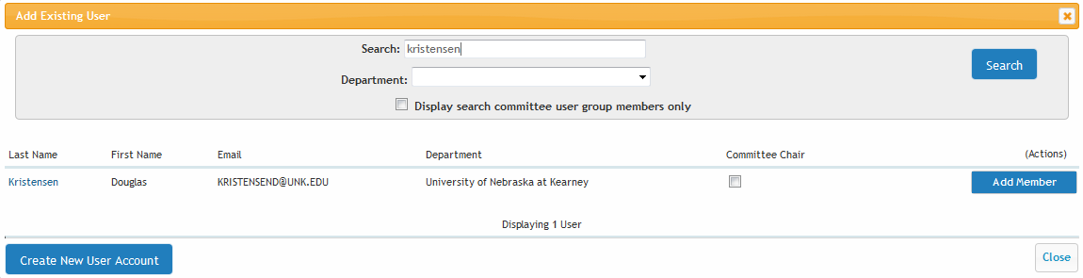

As the originator of the posting, you will not automatically be added as a search committee member. You must add yourself, and if applicable, make yourself the committee chair.

If you cannot find the user you wish to add, click the blue button and complete the fields. The request will be sent to Human Resources to add the user.
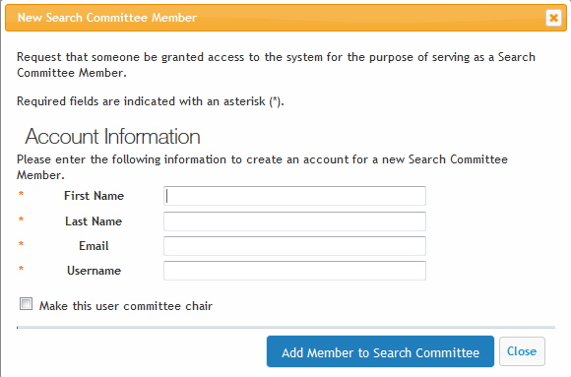

Click
Make sure to click Save or Next to update any changes. You will be able to save changes even if you do not have all of the required fields completed. The system will automatically log you out after 60 minutes of no activity.

Supplemental Questions (Optional)
Supplemental Questions are individual questions that can be used to qualify/disqualify applicants, or help as search criteria to narrow a pool of applicants based on their response. You may create those questions in this section.
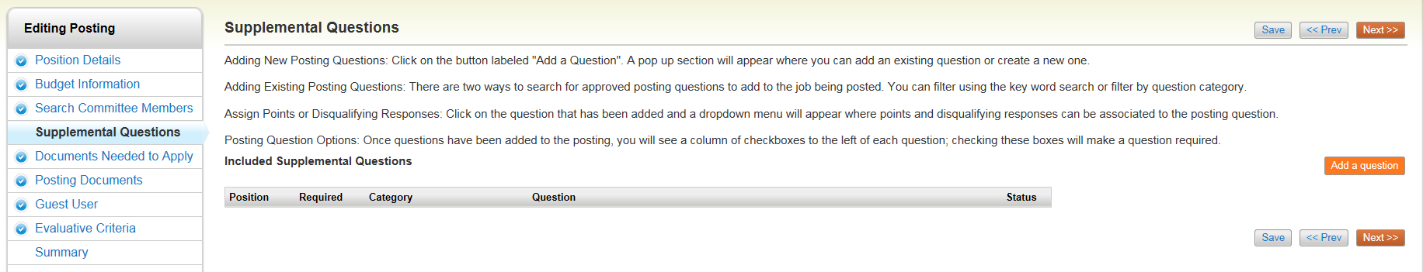
To add a Supplemental Question to this Posting, click , which returns the following page:
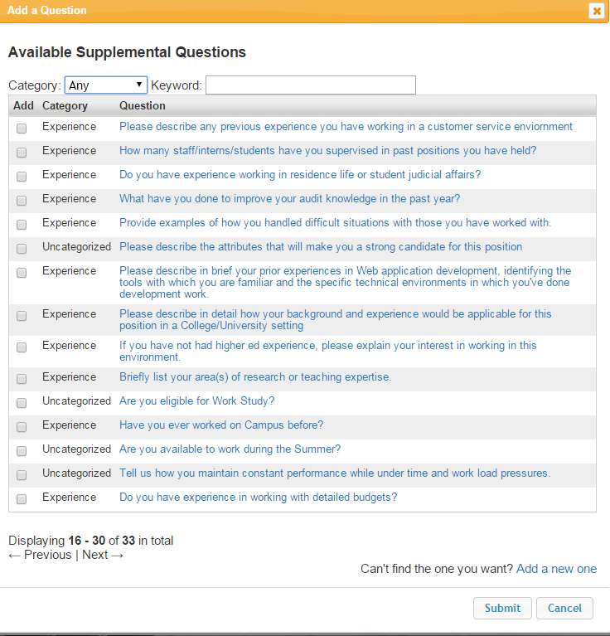

Search Existing Questions
The first step is to search existing questions. You can enter a keyword to search the question text (or leave the field blank). The system will return a list of all questions that have been approved by Human Resources. Select one of the questions from the list if it is appropriate for this Posting.

Add a New Question
If you do not find an applicable sample question from the list, click Add a new one.

Step 1: Enter question name, category and question text.
Enter the text of the question you wish to ask all candidates who will apply to this Posting. (Status will default to pending until question is approved by HR)

Step 2: Select answer type:
Open Ended: Applicants will be given a text box to type in their answer
Predefined: Applicants will be given a list of answers to select from
It is recommended to use predefined answers

Step 3: If you chose Open Ended Answers, click submit

Step 4: Predefined Answers questions require a multiple-choice answer. Input all possible responses.

Open Ended Question Example
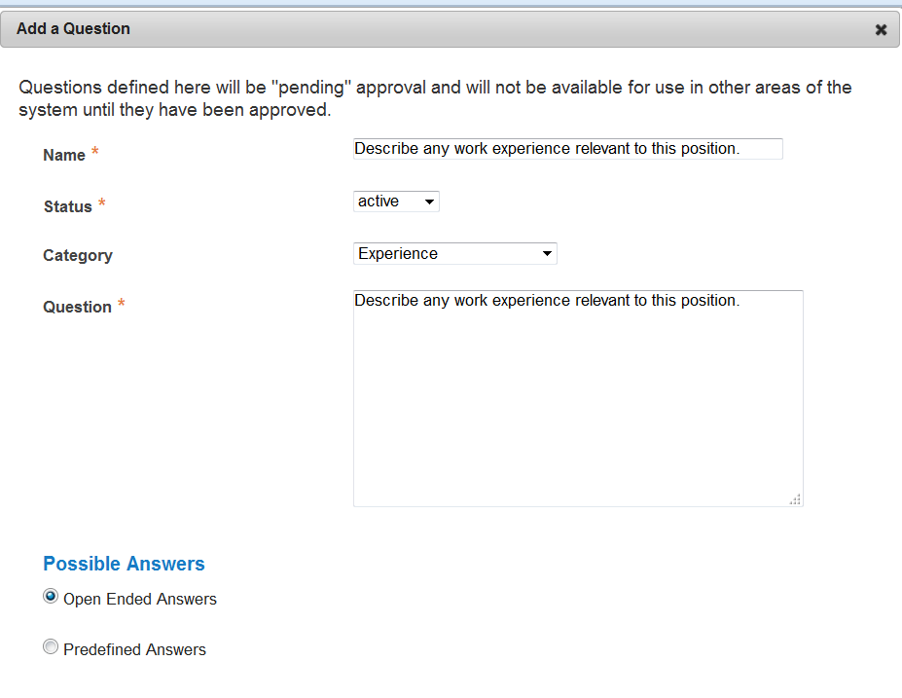
Describe any work experience relevant to this position.

Predefined Question Example
How many years of office experience do you have?
Possible Responses: 0, 1-2, 3-4, 5-6, 7+
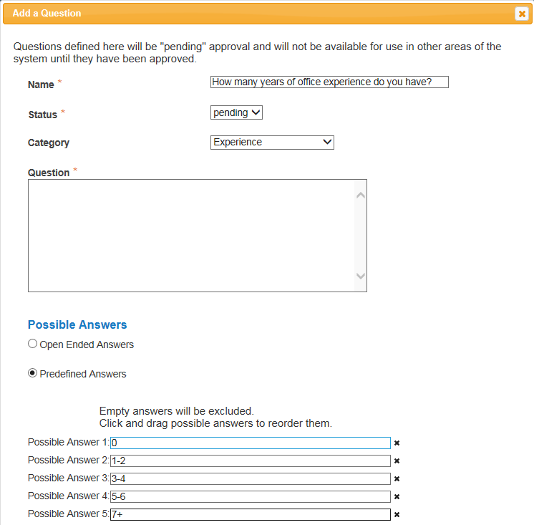

Step 5: Click on the Submit button at the bottom of the screen. This attaches the question to the Posting.

After you click Submit Question, you should see a screen similar to the following. This screen summarizes the question(s) you have entered. As you enter additional questions, they will be added to this summary screen.

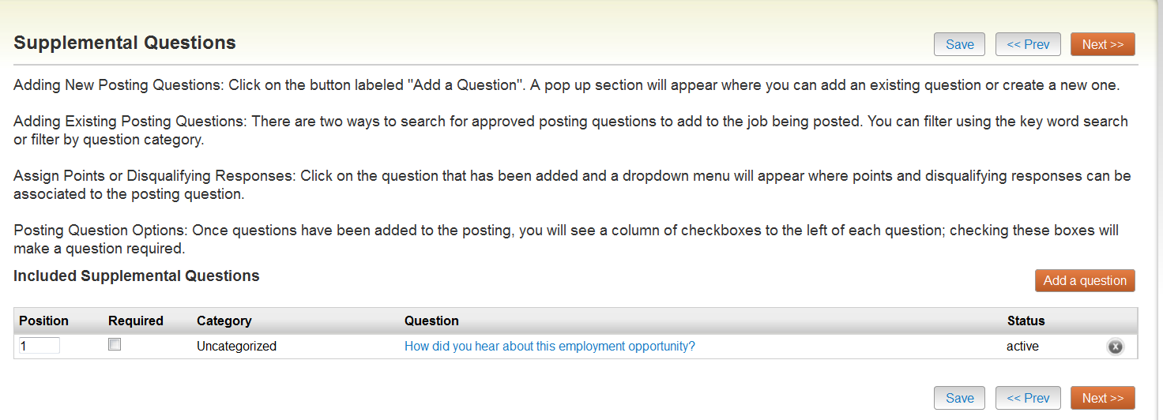

From this screen you may continue to add more questions by clicking the Add a Question button. You may also delete a question you have entered by clicking the x next to the relevant question.

Required Questions
You also have the ability to require an applicant to provide an answer to the question you added. The applicant will not be allowed to proceed without answering a question with the “Required” status. To require the question, check the required box.

Disqualifying Responses
If you wish to make a response a disqualifying response click on the question link. Check the box next to each response you wish to make a disqualifying answer . If you mark a response as disqualfying, the applicant will receive an email immediately after completing the application informing them that they are not qualified for the position. Disqualfying responses should align with Required Qualifications. Use this feature carefully.

Assigning Points Value
If you wish to assign points to a particular response, click on the question link. This is often done to help find the most qualified candidates quickly and to help narrow a pool of applicants. You do NOT have to use this functionality to use supplemental questions.
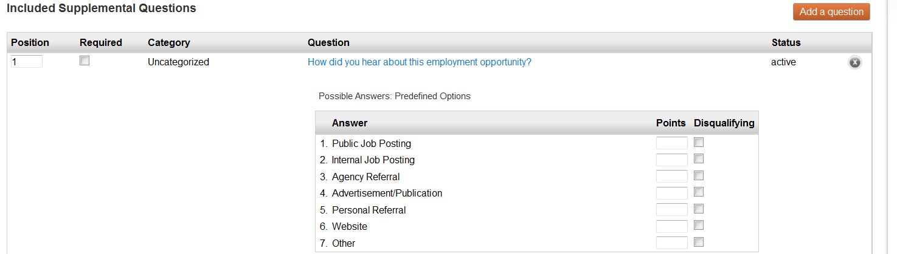

Click
Make sure to click Save or Next to update any changes. You will be able to save changes even if you do not have all of the required fields completed. The system will automatically log you out after 60 minutes of no activity.

Documents Needed to Apply
On this screen, you will designate the documents that will be necessary for applicants to apply to this posting. You can make this determination on a posting by posting basis. If a document is optional, select the Optional radio button, if it is required, select the Required radio button. Applicants will not be able to complete their application without uploading the required documents.

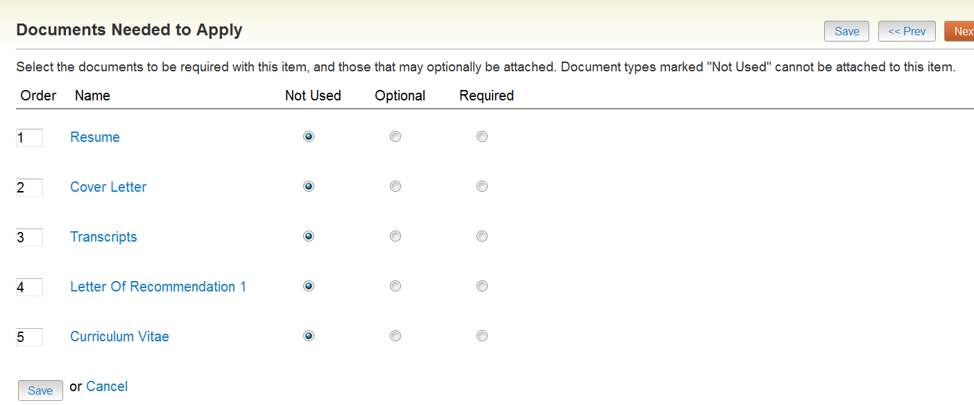
Click
Make sure to click Save or Next to update any changes. You will be able to save changes even if you do not have all of the required fields completed. The system will automatically log you out after 60 minutes of no activity.

Posting Documents
On this screen, you will add internal documents for approval. Please upload Word Documents only. To attach a document, click on the orange action next to the document name. From there you will be able to browse and attach the document to the posting.
Required: Advertisement (If different than Position Announcement), Interview Questions, Reference Questions, Search Criteria

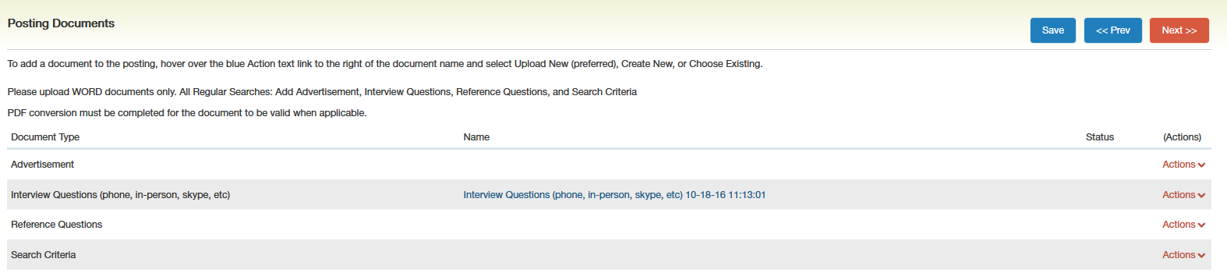
Click
Make sure to click Save or Next to update any changes. You will be able to save changes even if you do not have all of the required fields completed. The system will automatically log you out after 60 minutes of no activity.

Guest User
Guest Users are only able to view the applicants and postings that they are assigned to, and are not permitted to take action on any of the applicants. When the Posting is filled, the guest user name and password are automatically deactivated. This feature can be used for individuals who are not normal users in the PeopleAdmin system, i.e. students, employees from another university, community member, etc.
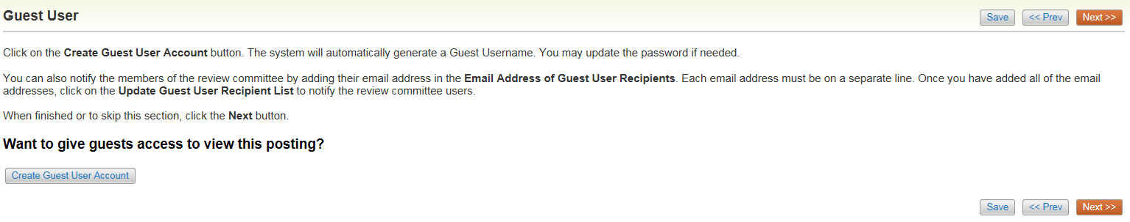
Click on the Create Guest User, the system will generate a Username and the password will also auto generate. If you want to change the password, update the password and then click on Update Password. Enter the email addresses of anyone you want to send the guest user credentials to and click Update Guest User Recipient List.

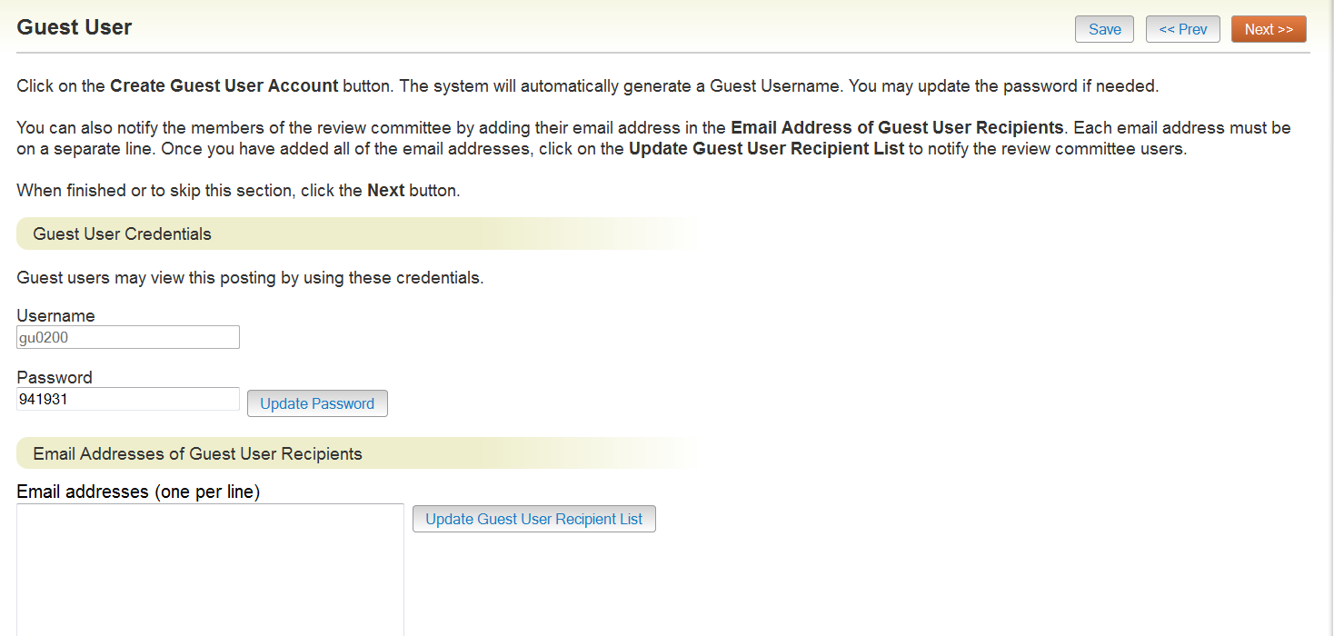
Click
Make sure to click Save or Next to update any changes. You will be able to save changes even if you do not have all of the required fields completed. The system will automatically log you out after 60 minutes of no activity.

Evaluative Criteria
This section is not currently being used. To skip this section, Click .

Summary
The system will then bring you to a summary page where you can review the posting and move to the next level approver. If any of the required fields are missing, you will see an exclamation point.

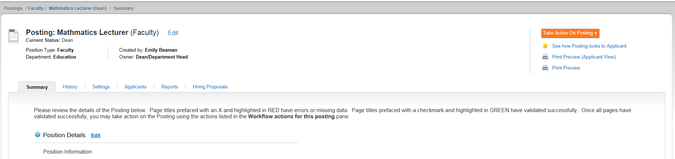
To move the posting to the next approver, hover over . Click Approve to move to the next approver. If there is more than one option, and you do not know which one to choose, please contact HR. You can also select Keep Working on this Posting if you are not ready to approve the posting, or if you need to make changes.

The system will generate an email to the next approver and this posting will appear in their inbox for their approval. The posting will continue through the approval process until Human Resources will post the position.

